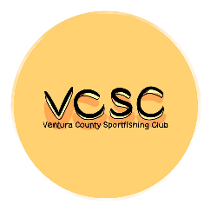
p

MEMBERSHIP APPLICATION (2026)
VENTURA COUNTY SPORTFISHING CLUB (VCSC)
PO BOX 302, MOORPARK, CA 93020
https://vcsc.info/

PRIMARY MEMBER / FIRST & LAST: ________________________________________________________

SPOUSE / FIRST LAST: ____________________________________________________________________

ADDRESS: _________________________________________________________________________________

CITY: ____________________________________________ STATE: _________ ZIP: ___________________

EMAIL ADDRESS: _________________________________________________________________________

CELL/TEXT PHONE: ______________________________________________________________________

HOME PHONE: ___________________________________________________________________________

EMERGENCY CONTACT:

NAME: ___________________________________ PHONE: _____________________________________

I understand that the Ventura County Sportfishing Club, as a whole or any individual member, will not be held responsible for any physical injury or loss/damage to personal property while participating in any of the club functions.

I also agree to abide by all rules and regulations of the club, and current fishing regulations.

Signature: _______________________________________________ Date: _________________________

Any questions? Contact either VCSC member below:
- Art Hernandez / President & Membership Chair: iorart4431@gmail.com / 805-338-4653

Dues are $60 per year. Make a check out to VCSC. Mail your application to the address above or bring it to one of our club meetings with payment.

ZELLE payment: (1) pay to: venturacountysportfishingclub@gmail.com (club’s gmail account).
(2) Select an amount (3) It will then say pay to: VENTURA CO. BLUEWATER SPORTFISHING CLUB
(4) Select “pay”.

** Any questions? Email VCSC Treasurer, Rick Lane at: venturacountysportfishingclub@gmail.com

